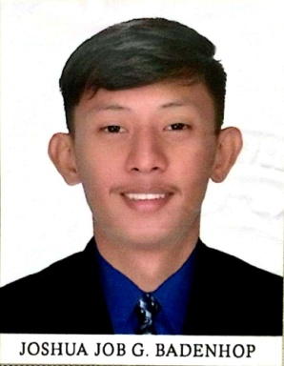**BIO-DATA**

**PERSONAL DATA**

Position Desired: Helper

Name: Badenhop, Joshua Job G. Sex: Male

City Address: Batangas City

Provincial Address: Aplaya, Bauan, Batangas

Cellphone Number: 09664415811

Email Address: [joshuabadenhop@gmail.com](mailto:joshuabadenhop@gmail.com)

Date of Birth: October 04,2000

Place of Birth: Jose Fabella Memorial Hospital,Sta. Cruz,Manila

Civil Status: Single Citizenship: Filipino

Height: 5’10 Weight: 63 kgs.

Religion: Roman Catholic

Father’s Name: Joseph Albert Q. Badenhop Occupation: N/A

Mother’s Name: Emerita G. Badenhop Occupation: N/A

Parent’s Address: Brgy. Pusil,Lipa City

Language/Dialect spoken&written: Tagalog and English

Person to be contacted in case of emergency: Emerita G.Badenhop Cellphone No. 09283333076

**EDUCATIONAL ATTAINMENT:**

Elementary: West Bauan Central School Year Graduated: 2013

High School: Alternative Learning System Year Graduated: 2019

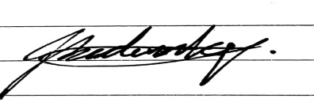College: N/A

Degree Received: N/A

Special Skills: NC 1/Welder

**Applicant’sSignature**

I hereby certify that the above information is true and correct to the best of my knowledge and belief. I also understand that any misinterpretation will be considered sufficient reason for withdrawal of an offer or subsequent dismissal if employed